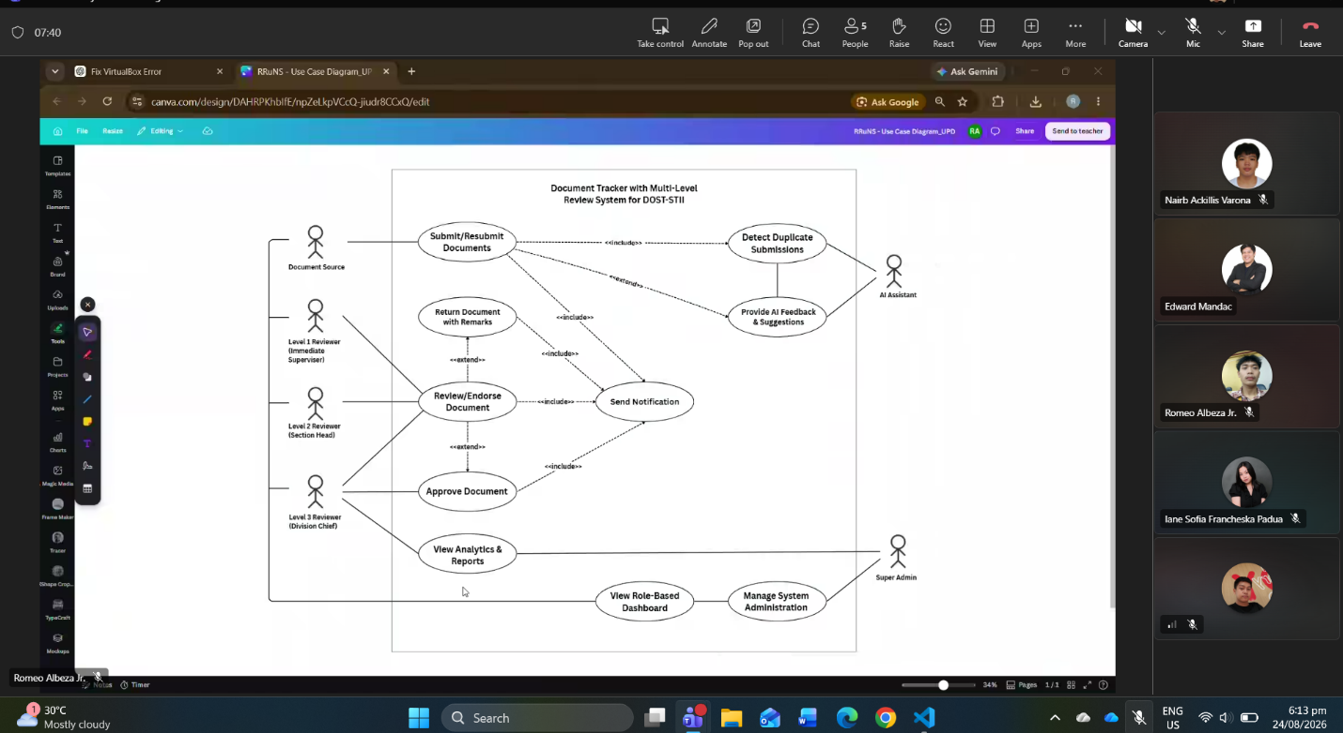
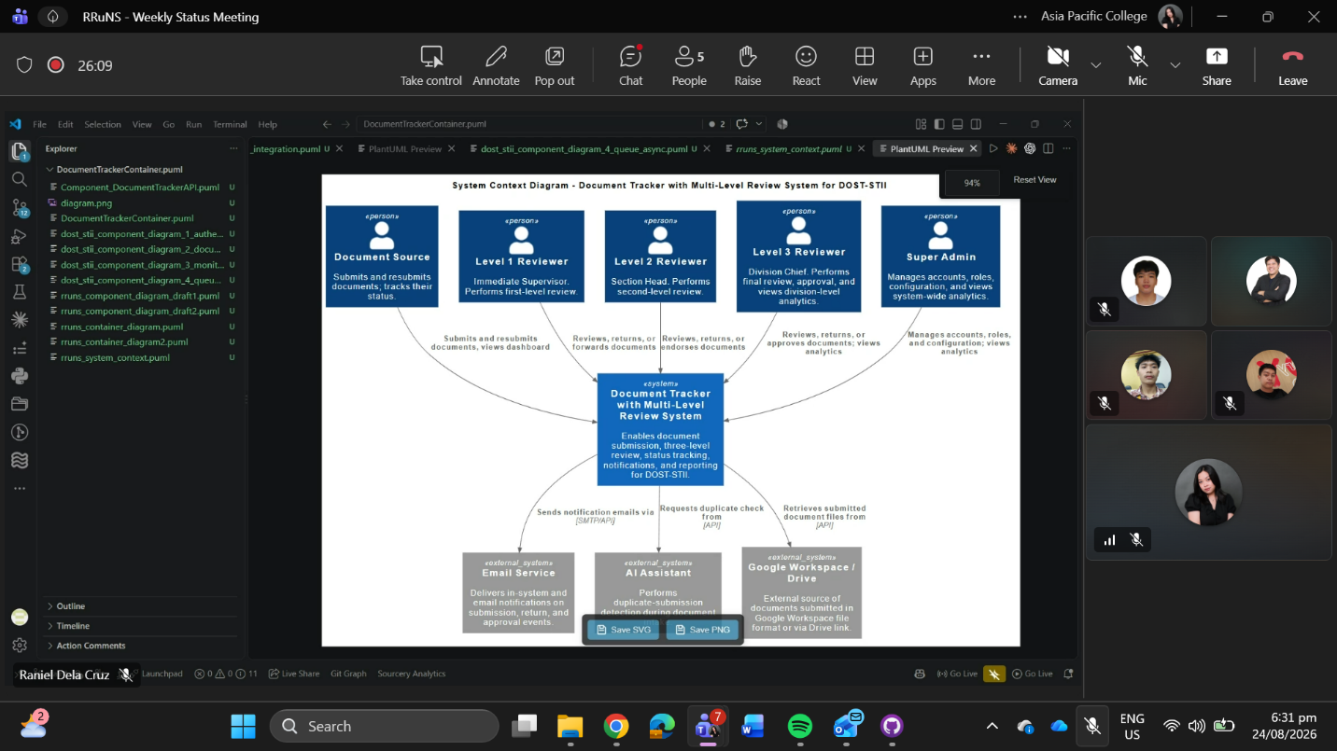

Weekly Status Report: Minutes of Meeting
- Date: Monday, August 24, 2026
- Meeting Called By: RRuNS Team
- Facilitator: Edward Mandac
- Link of the Meeting: RRuNS - Recap: RRuNS - Weekly Status Meeting Monday, 24 August | Meeting | Microsoft Teams
1. Attendees
- Nairb Ackillis Varona
- Romeo Jr. Albeza
- Iane Sofia Francheska Padua
- Raniel Q. Dela Cruz
2. Agenda
- Discussion of test case
- Discussion of use case diagram
- Discussion of C4 diagram
3. Summary
- Status update for the week:
  - The team reviewed and discussed the test cases to ensure proper validation of system features and functionalities.
  - Examined the structure, feedback, and final refinements needed for the use case diagram.
  - Covered the architecture and components of the C4 diagram to ensure alignment with system design specifications.
- Blockers/Obstacle that encountered this week:
  - Ensuring complete alignment and integration between the system's test cases, architectural diagrams, and overall documentation requirements.

